
Name: Javeria Kanwal
Roll No: 26
Instructor: MAM FARHAT
Class: BSCS
Date: 12/18/2023

PROGRAMMING FUNDAMENTAL
PF Semester Project Report
C
yber café management system

Cyber café management system is a desktop application for systematizing the record storage and facilitating other transaction or financial activities. It is a simple application/software that automates many activities and increase the efficiency and accuracy of work in cyber.
It enables the admin to log onto the system and add the PC’s that are available in cyber, Also, he/she can remove the PC from the list if it is malfunctioning and update it later after it is repaired. Only the admin has privileges to add, update or delete the PC. User or the one who runs the cyber can simply initiate the time in the slot if somebody wants to use the PC. The time is calculated and when he/she wants to use internet and then it displays the final time along with the price that he/she needs to pay. In this way it systemizes and automate the system.

Code structure and functionality:
- Header and menus:
- The code begins with header graphics and defines various menus and submenus for managing computer records and user interactions.
- Authentication and user management:
- Includes functionalities like login, password change, and registration.
- Two user profiles: Admin and user, each with different access levels and privileges.
- Record handling:
- Manages computer records with arrays for computer names, locations, and numbers.
- Functionalities to display, update, and search computer records.
- Biling system:
- Calculates and displays the bill based on usage time and charges per minute for the user profile.

Function overview:
- Main():
- Initialize the program, displaying the header and main menu.
- Functions for menus:
- mainmenu(), menu(), login page(), etc., manage different levels of menus and user interactions.
- User functions:
- user() for billing purposes.
- login(), change password(), and registration() for user authentication and management.
- Record management functions:
- show record(), update record(), search(), handle displaying, updating, searching computer records.
Potential improvements:
- security enhancement:
- Implement stronger password handling (encryption, secure storage).
- Add input validation for username/ password changes and registrations.
- Code refactoring:
- Modularize functions further for better readability and maintenance.
- Optimize repetitive code segments to improve efficiency.
- Error handling:
- Incorporate error handling mechanisms for invalid inputs or unexpected behaviors.
- Expand functionality:
- Include more features like deletion of records, sorting options, or additional user roles.
- Documentation:
- Include comments within the code to explain complex sections or functionality.
File handling:
- File input/ output:
- The program uses file handling to read and write user credentials. It reads and writes usernames and passwords from a file named “credentials.txt” for user login and registration purposes.

Main Output page:
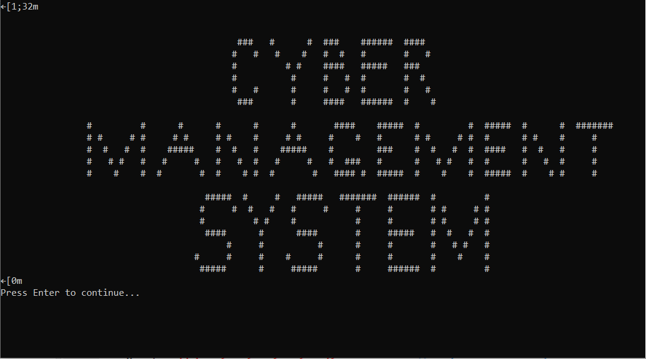

Main menu:
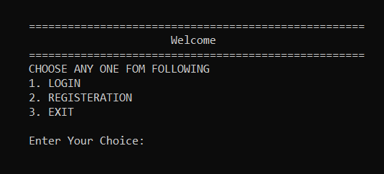

- For user login: press 1.
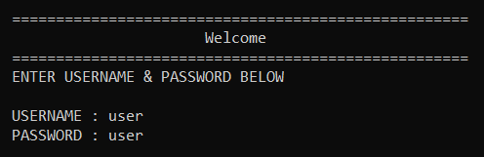

After login admin will ask the time from user and insert the time the bill will generate.
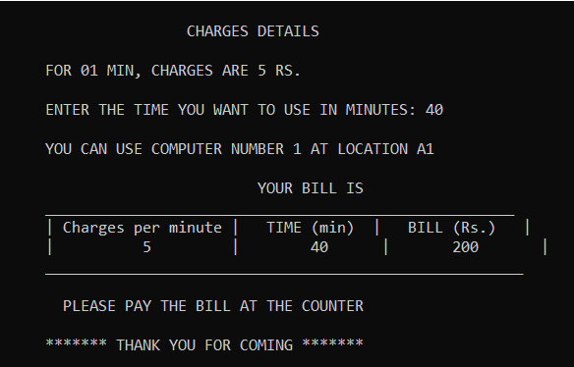

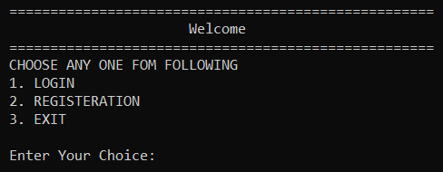
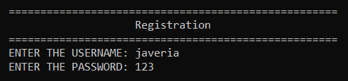
- For admin registration: press 2.
After Registration admin will login:
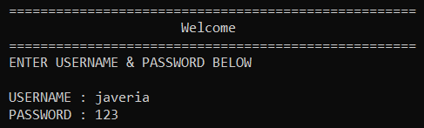

After login 6 options will be shown to Admin:

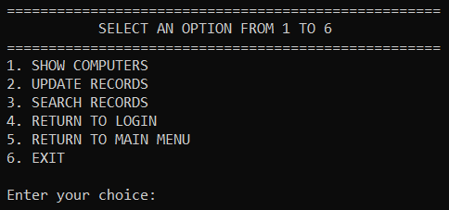

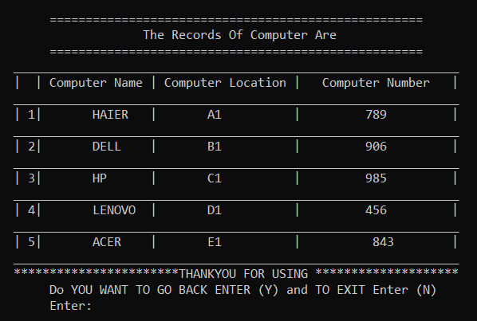
Option 1 to Show all computers:
By pressing (Y, y), it will bring you to selection panel. By clicking (N, n), the program will end.

Option 2 to Update all records:
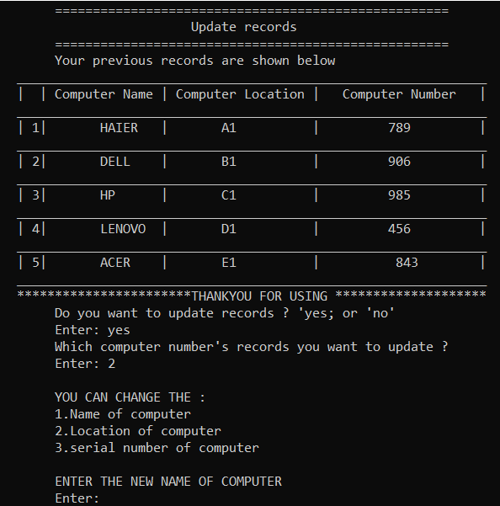

Option 3 to Search records:
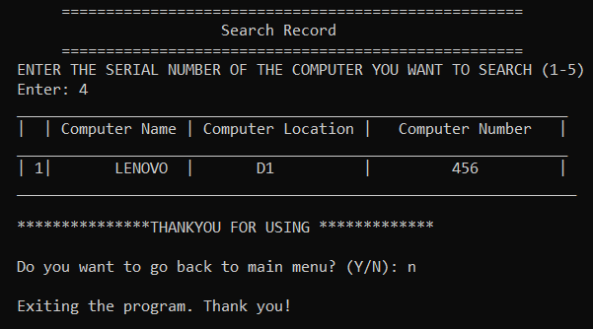

Option 4 to Return to login page.
Option 5 to Return to Main Menu.
Option 6 to Exit the program.

Conclusion:
The code is a basic system for managing computer records, user authentication, and billing functionalities. While functional, it requires some enhancements in term of security, functionality, and code organization for better usability and maintenance.



